MCS9865
Linux Driver User Manual

Table of Contents

1.Introduction 2
2.Drivers Location 2
3.Serial Port Installation 2
4.Serial Port Settings 5
5.Parallel port installation 6
6.ISA ports installation. 7
7.Un-installation of the Drivers 8
8.Technical Support 8
Revision history: 9

Introduction
This document describes the software driver installation / Un-installation procedure for MosChip MCS9865 PCI to Serial / Parallel products or other manufacturer’s product based on MosChip MCS9865 series on Linux OS.

Drivers Location
MCS9865 Linux source code can be downloadable from www.moschip.com.

Serial Port Installation
  - Copy the downloaded driver disk to the desktop.
  - Shutdown the PC, insert the MCS9865 based PCI card into PCI Slot and then Switch ON the PC.
  - Check for the MCS9865 PCI Card detection by typing the following command in terminal window. “lspci –v ”. This will show the list of all PCI ports. Check for the Product ID 9865 as shown below.

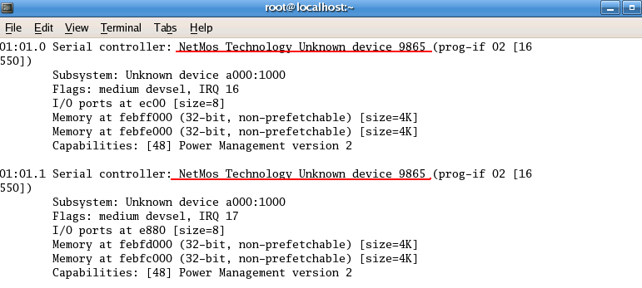

- Untar (Uncompress) the driver disk copied to the desktop by using following command. Make sure that you change the path of terminal on to the desktop.

$ tar –xzvf MCS9865_V1.2.tar.gz

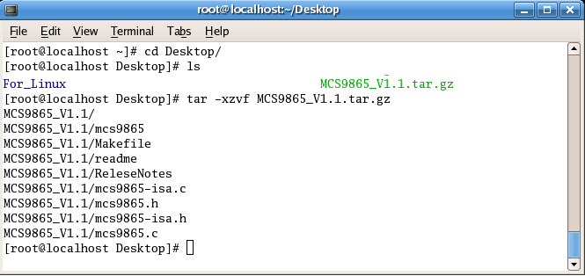

- Change the path of the terminal to the path of extracted files.
$ cd /MCS9865
- Compile the driver using the command “make”. No errors should be displayed.

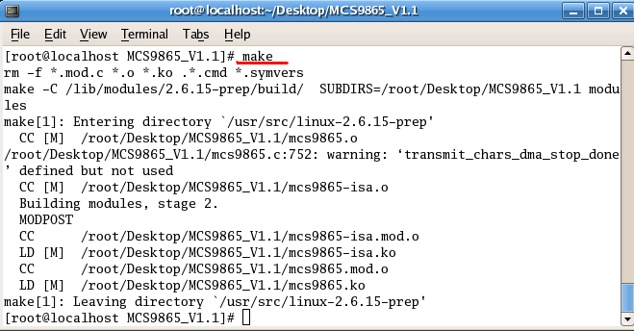

- Install the driver using the following command
$ make install
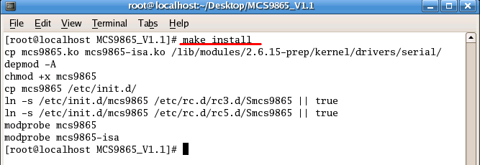

- MCS9865 PCI Card installation is complete and the device is ready to use.
- Type “ls /dev/ttyD” command in the terminal window and press “Tab” key twice to see the MCS9865 serial ports installed on the machine.

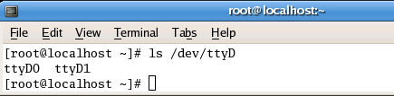

Serial Port Settings
The serial port settings can be changed by editing the “MCS9865.c” file. To edit the file use the command:
$ vim MCS9865.c
Note: Make sure that the path of the terminal points to the same folder where MCS9865.c file is present.
MCS9865 Serial Ports supports following configurable serial features like:
- Serial port mode
- DMA in RX
- DMA in TX
- Enable/Disable Flow control
- Flow control type
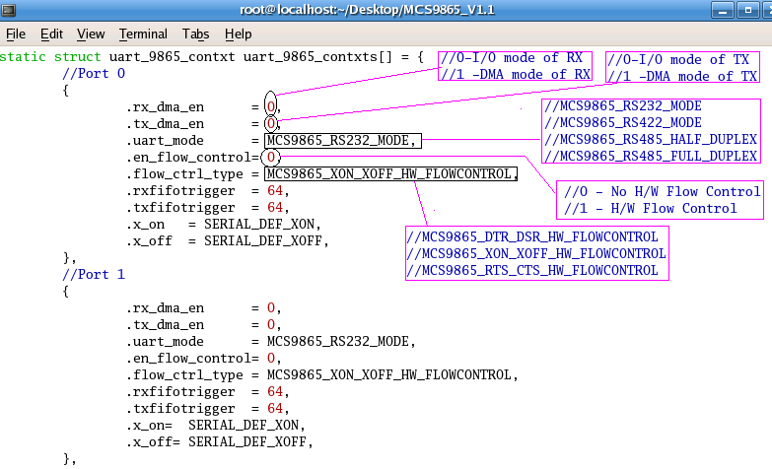
Note: To set the mode from RS-232 mode to RS-422/485 mode or vice versa, we need to compile the driver. If the driver is already installed, uninstall the driver, compile (Make) and install the driver.

By default MCS9865 Serial port properties will be set to RS-232 mode, DMA enabled and Hardware Flow Control disabled.

To change the Serial port settings the values must be edited accordingly as Follows:

To enable Receive DMA of the selected serial port replace 0 with 1 against “rx_dma_en” field.
To enable Transmit DMA of the selected serial port replace 0 with 1 against “tx_dma_en” field.
To configure the Serial in different Modes change the entire string “MCS9865_RS232_MODE” as follows:
- For RS 232 Mode: MCS9865_RS232_MODE
- For RS 422 Mode: MCS9865_RS422_HALFDUPLEX (For Half duplex Functionality)
- For RS 485 Mode: MCS9865_RS485_FULLDUPLEX (For Full duplex Functionality)

The values can be seen in the same document. The first screen shot displays the setting modes.
For example: RX DMA can be disabled by replacing 0 with 1. All other values can be changed in the same way.

Port 0 in the above picture represents the settings for the first port and similarly other numbers represent the same for other ports.
After editing this file save and exit the file by using the command:
Press “Esc” key and type :wq! and press enter.

Note: The present Linux serial driver supports only up to 2x baud rate.

Parallel port installation
To install the parallel port use the following command
modprobe parport_pc io=0xe800, 0xdd00 irq =3
The first io address 0x378 and the first irq address points the standard parallel port and the second io and irq addresses points the MCS9865 io and irq values.

To check the “io” and “irq” addresses use the command “lspci -v”.
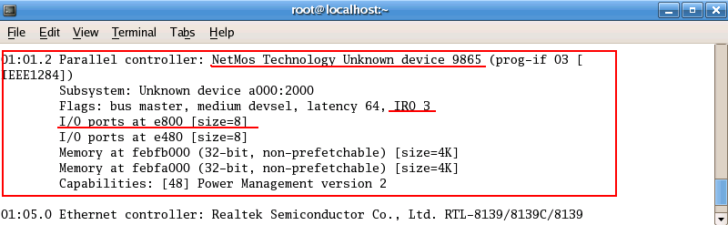

MCS9865 parallel port supports SPP/CBFIFO/ECP/EPP modes. Parallel port will automatically move into the device mode (SPP/CBFIFO/ECP/EPP) by handshaking.

ISA ports installation.
ISA serial and parallel port installation follows the same procedure as serial port and parallel port installation. ISA serial port uses standard drivers and there are no properties like DMA and Flow Control mechanisms also has no support of RS422/RS485 on ISA serial ports. ISA based serial ports has support of 1X speed only.

Note: The serial ports using ISA will get detected as ttyS(x), where x indicates the port number.

Un-installation of the Drivers
To un-install the driver use the command
$ make uninstall
$ Symbol represents the shell prompt in linux.
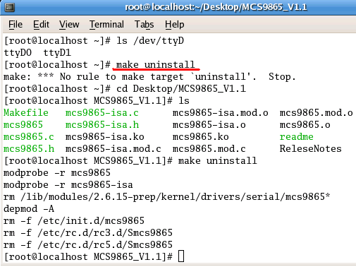

Note: Use “make clean” command before changing the serial property page.

Technical Support
Contact sales@moschip.com for commercial details
Write to techsupport@moschip.com for technical queries

Revision history:

Date | Reason for change | Version
6th Jun 2008 | Initial Document | 1.1

IMPORTANT NOTICE

MosChip Semiconductor Technology, LTD products are not authorized for use as critical components in life support devices or systems. Life support devices are applications that may involve potential risks of death, personal injury or severe property or environmental damages. These critical components are semiconductor products whose failure to perform can be reasonably expected to cause the failure of the life support systems or device, or to adversely impact its effectiveness or safety. The use of MosChip Semiconductor Technology LTD’s products in such devices or systems is done so fully at the customer risk and liability.

As in all designs and applications it is recommended that the customer apply sufficient safeguards and guard bands in both the design and operating parameters. MosChip Semiconductor Technology LTD assumes No liability for customer’s applications assistance or for any customer’s product design(s) that use MosChip Semiconductor Technology, LTD’s products.

MosChip Semiconductor Technology, LTD warrants the performance of its products to the current specifications in effect at the time of sale per MosChip Semiconductor Technology, LTD standard limited warranty. MosChip Semiconductor Technology, LTD imposes testing and quality control processes that it deems necessary to support this warranty. The customer should be aware that not all parameters are 100% tested for each device. Sufficient testing is done to ensure product reliability in accordance with MosChip Semiconductor Technology LTD’s warranty.

MosChip Semiconductor Technology, LTD believes the information in this document to be accurate and reliable but assumes No responsibility for any errors or omissions that may have occurred in its generation or printing. The information contained herein is subject to change without notice and no responsibility is assumed by MosChip Semiconductor Technology, LTD to update or keep current the information contained in this document, nor for its use or for infringement of patent or other rights of third parties. MosChip Semiconductor Technology, LTD does not warrant or represent that any license, either expressed or implied, is granted to the user.

Copyright © 2007 MosChip Semiconductor All Rights Reserved.

